Once on This Island 2012
Willowcreek Middle School

Dearest Parents,

We are thrilled to have your student in our musical theater class. In this packet, you’ll find some helpful information as we navigate this next semester. You will find a copy of the rehearsal schedule, costume requirements, prop requests, and a volunteer form. Please look these over and don’t hesitate to contact Ms. Jennings or Mrs. Grace if you have any questions.

This year we have made our school musical into a class. The purpose of this is two fold: it requires far less time after school for your student and it gives twice the amount of students the opportunity to perform. We are excited and can’t wait for you to see the fruits of their labor in April.

Our current class has 84 students in it. We will be double casting the show so every person will (hopefully) have someone playing exactly their same part. The auditions for specific parts will be happening in the next couple of weeks in class. You are welcome to come in an observe at anytime!

Sincerely,

Ms. Jennings, Mrs. Grace, and Mrs. Stout

Once on This Island Plot Synopsis & List of Characters
Source: www.wikipedia.com

One stormy night, thunder booms, making a small girl cry in fear. To comfort her, the villagers tell her the story of Ti Moune, a peasant girl who falls in love with a grand homme, Daniel Beauxhomme. A story of life, pain, love, grief, faith, and hope.
In this story, four gods (Asaka, Mother of the Earth; Agwé, god of Water; Erzulie, goddess of Love; and Papa Ge, Demon of Death) rule an island, the Jewel of the Antilles, which in real life is Haiti, where poor Peasants worship them (Prologue/"We Dance"). The peasants, "black as night", live on one side of the island, and the Grandes Hommes, lighter skinned descendants of the original French planters and their slaves, live on the other. One day, Agwe unleashes a terrible storm upon the island, which in turn causes a disastrous flood, wiping out many villages. However, the gods save the life of little Ti Moune, an orphan, by placing her in a tree, above the flood's waves. She is found and subsequently adopted by the peasants Mama Euralie and Tonton Julian ("One Small Girl").
Years after, Ti Moune, grown up, prays to the gods to know her purpose, and to let her be like the fast-driving strangers on the roads near her village - the Grand Homme ("Waiting for Life"). Hearing her plea, the Gods laugh at her. However, Erzulie says to give her love, because it is stronger than any of the other elements. Papa Ge, offended, proposes a bet to prove which is stronger: love or death. Agwe arranges for the car of Daniel Beauxhomme, a young Grande Homme, to crash during a storm so that Ti Moune may meet Daniel and restore him to health ("And The Gods Heard Her Prayer/Rain"). Despite the objections of the other peasants, including her own parents, Ti Moune helps the intruder (Daniel) to recover ("Pray"). Ti Moune falls in love with the stranger and, as she cares for the unconscious boy, imagines he loves her too. When Papa Ge comes to take Daniel's life, Ti Moune offers her life in exchange for Daniel's so that he will not die ("Forever Yours"). Papa Ge is angry but leaves, hinting he will return – sooner or later, as her life now belongs to him.
Tonton travels to the other side of the Island to seek Daniel's family at the Hotel Beauxhomme. When Tonton returns, he brings with him the story of Daniel's people ("The Sad Tale of the Beauxhommes") as well as some of Daniel's people to take the boy back. Ti Moune is tearfully separated from Daniel and tells her parents that she will go after Daniel to marry him. Ti Moune's parents reluctantly let her go ("Ti Moune"). During her travels, she encounters the goddess Asaka, who tells her not to fear, as the Earth will give her everything she needs on her journey to Daniel ("Mama Will Provide"). When she reaches the other side of the island, the storytellers relate the different versions of her impossible journey to the city (including being forced to wear too-tight shoes, a parallel to the Little Mermaid's pained steps) through the hotel gates and finding Daniel's room ("Some Say"). Daniel, still ill and unable to walk, does not remember her but believes her after she describes the scar on his chest. As they stay together, Erzulie gives them the gift of love ("Human Heart"). Daniel ignores the townspeople's gossiping ("Pray" - Reprise) over the unlikely relationship of a rich Beauxhomme and a poor peasant. Daniel delights in Ti Moune's differences from the rich girls in his life, noting "some you marry, some you love." ("Some Girls")
At a ball held at the hotel, Andrea Deveraux, a daughter of Daniel's family friends, cajoles Ti Moune to dance for them (her ulterior motive is to make her look bad in front of the Grand Hommes). Daniel encourages her to dance as she has in the past for him ("Ti Moune's Dance") and she gains the admiration of the rich society members. Afterwards, Ti Moune learns that Daniel is engaged to be married to Andrea ("When We Are Wed"). Daniel, reminded of his responsibilities, must go through with the arranged marriage, although he insists they can be lovers forever. Ti Moune is crushed. Papa Ge reappears and reminds Ti Moune of her promise to exchange her life for Daniel's – but says she can revoke the bargain if she kills Daniel, just as Daniel had killed their love (Promises/Forever Yours Reprise). Ti Moune enters Daniel's room with a knife, but she still loves him too much to kill him - proving love is stronger than death. However, Daniel finds Ti Moune with the knife. Appalled at the attempted murder, the Beauxhommes throw her out of the hotel grounds. She waits for days to meet Daniel at the gate. As Daniel and Andrea are married, they follow an old tradition of throwing coins to the peasants outside the hotel gates - Ti Moune calles to Daniel, who places a silver coin in Ti Moune's hand and leaves. The storytellers tell how Erzulie took her by the hand and led her to the ocean, where Agwé allowed her to drown peacefully, Papa Ge received her gently and brought her back to shore, where Asaka transformed her into a tree. ("A Part Of Us").
The tree becomes a celebration of life and love that cracks open the gates of the hotel, allowing those of all social statuses to become one. Her legacy brings together a peasant girl and a young Grande Homme, Daniel's son, as they play in her branches. The storytellers share them message of retelling the story of how a peasant girl proved the power of love to bring together the people of the island. It helps us to remember, to forgive - and out of what we live and we believe, our lives become the stories that we weave. As the musical ends, the little girl who was frightened by the storm begins to retell the story herself. ("Why We Tell The Story").

Characters
- Ti Moune, a peasant girl
- Daniel Beauxhomme, a Grand Homme; Ti Moune's love interest, also "Beauxhomme", the beautiful man
- Papa Ge, sly Demon of Death; the main antagonist of the show. He tricks the main character into giving her life for another. He is seen as a skeleton and is very sneaky. The people on the island fear him because of what he represents: the unknown that is death.
- Erzulie, beautiful Goddess of Love; the foil to Papa Ge. She is triumphant in the show, as she proves that love does conquer death and withstand all.
- Agwe, God of Water; the main catalyst for the action of the show.
- Asaka, Mother of the Earth
- Mama Euralie, Ti Moune's adoptive mother
- Tonton Julian, Ti Moune's adoptive father
- Andrea Deveraux, Daniel's promised wife; also "Madame Armand"
- Armand, Daniel's stern father; also "Armand", the ancestor
- Gatekeeper, the Hotel Beauxhomme's fierce guard (commonly played by Armand)
- Little Ti Moune, Ti Moune as a child; also "The Little Girl"
- Daniel's Son, Daniel's young son (commonly played by Daniel)
- Storytellers/Gossips, various Grands Hommes and peasants (in most productions, the storytellers are shown as playing the parts of the Gods)

Once on This Island Rehearsal Schedule

We are doing most of our rehearsals after school. However, we still have to have some vitally important rehearsals after school. There simply isn’t the time to run through an entire show in a 70 minute class period. We’ve tried to make our rehearsal schedule in such a way that it impacts you in the most minimal way possible. What that means for you is that every rehearsal is important. Please do your best to make sure that you have made arrangements to have your student be at his or her assigned rehearsals. If there is an emergency please email or call the school as quickly as you can to let us know. Where possible, please arrange scheduling conflicts with your student’s double so that we are not missing any cast members at a rehearsal. Rehearsals are also directly tied to your student’s participation grade. We will be following the Willowcreek Performing Arts Contract for grading procedures for mandatory rehearsals and performances.

No one can miss rehearsal during the two weeks before we open. No exceptions.
When | Time | What We’re Rehearsing | Who
Wednesday  January 18t^{th} | In Class | Disclosure Document, Performing Arts Contract, Musical Theater Project | EVERYONE
Friday  January 20th | In Class | Getting to Know You | EVERYONE
Tuesday January 24th | In Class | Music/Dance/Theater History | EVERYONE
Wednesday January 25th | 6:00-6:45 p.m. | Musical Theater Parent Meeting | Parents of all Musical Theater Students
Thursday  January 26th | In Class | Introduction to Once on This Island (OOTI) | EVERYONE
Monday  January 30th | In Class | Finish OOTI Read Through, Introduction of the director’s concept | EVERYONE
Wednesday February 1st | In Class | How To Audition  Acting/Singing | EVERYONE
Friday February 3rd | In Class | How to Audition  Dance | EVERYONE
Tuesday February 7th | In Class  2:45-4:15 | Vocal Auditions in class  Teach Dance Routine After School | EVERYONE  EVERYONE
Thursday February 9th | In Class | Dance Auditions | EVERYONE
Monday February 13th | In Class  3:00-5:00 p.m. | Choreography with Mrs. Grace-TBA  Vocal rehearsal | EVERYONE  EVERYONE
Tuesday February 14th | 3:00-5:00 p.m. | Vocal Rehearsal | EVERYONE
Wednesday February 15th | In Class  3:00-5:00 p.m. | Choreography with Mrs. Grace-Mama Will Provide  Vocal Rehearsal | EVERYONE  EVERYONE
Thursday  February 16th | 3:00-5:00 p.m. | Vocal Rehearsal | EVERYONE
Friday February 17th | By 3 p.m. | First half of Musical Theatre Project Due | EVERYONE
Monday February 20th |  | NO SCHOOL—President’s day
Wednesday February 22nd | In Class  3:00-4:00 p.m. | Choreography with Mrs. Grace-Prologue/We Dance  Vocal Rehearsal | EVERYONE  Gods
Friday February 24th | In Class | Choreography with Mrs. Grace-Prologue/We Dance/Waiting for Life | EVERYONE
Tuesday February 28th | In Class | Choreography with Mrs. Grace-Rain | EVERYONE
Thursday March 1st | In Class | Choreography with Mrs. Grace-Sad Tale of the Beauxhommes | EVERYONE
Monday March 5th | In Class | Choreography with Mrs. Grace—Some Say | EVERYONE
Wednesday March 7th | In Class | Choreography with Mrs. Grace—Human Heart | EVERYONE
Friday March 9th | In Class | Choreography with Mrs. Grace—Promises/Forever Yours | EVERYONE
Tuesday March 13th | In Class | Choreography with Mrs. Grace—Why We Tell the Story | EVERYONE
Thursday March 15th | In Class | Blocking with Ms. Jennings  Dance Cleaning with Mrs. Grace | Gods, Timoune, Tonton, Mama, Selected Storytellers (Prologue/One Small Girl, Pray)  TBA
Monday March 19th | In Class | Blocking with Ms. Jennings | Ti Moune, Gods, Daniel,Storytellers (Waiting for Life, And the Gods Heard Her Prayer, Discovering Daniel, Pray)
Wednesday March 21st | In Class | Blocking with Ms. Jennings | Ti Moune, Daniel, Gods, Mama, Tonton, Beauxhommess (Forever Yours,Ti Moune, Sad Tale of the Beauxhommes)
Friday March 23rd | In Class | Blocking with Ms. Jennings | Gods, Ti Moune, Daniel, Beauxhommes, Daniel’s Father (Human Heart, Pray-reprise, The Ball)
MUST BE MEMORIZED FROM THIS POINT FORWARD!!
Tuesday March 27th | In Class | Blocking with Ms. Jennings | TBA
Thursday March 29th | In Class | Blocking with Ms. Jennings | TBA
Monday April 2nd | In Class | Blocking with Ms. Jennings | TBA
Wednesday April 4th | In Class | Run First Half | Cast B-Cast A watching
Friday April 6th | In Class | Run Second Half | Cast A-Cast B watching
No one can miss rehearsal from this point forward
Saturday April 7th | 9:00 a.m.-4 p.m. | SET BUILDING DAY!! | Anyone who can come and help
Monday April 9th-Friday April 13th |  | No School—Spring Break | EVERYONE
Monday April 16th | 3:00-5:30 p.m. | Run Through show with Costumes and Lights | Cast B
Tuesday April 17th | In Class  3:00-5:30 p.m. | Run First Half  Run Through show with Costumes and Lights | Cast A-Cast B Watching  Cast A
Wednesday April 18th | 3:00-5:30 p.m. | Run Show | Cast B
Thursday April 19th | In Class  3:00-5:30 p.m. | Run Second Half  Full Dress Rehearsal | Cast B-Cast A Watching  Cast A-Cast B Watching
Friday April 20th | 3:00-5:30 p.m. | Full Dress Rehearsal | Cast B-Cast A Watching
Saturday April 21st | 9:00 a.m.-12:00 p.m.  12:45-3:45 p.m. | Run Through with Notes  Run Through with Notes | Cast A  Cast B
Monday April 23rd | 3:00-6:30 p.m. | Dress w/Tech | Cast A
Tuesday April 24th | 3:00-6:30 p.m. | Final Dress w/Tech | Cast B
Wednesday April 25th | 3:00-6:30 p.m. | Final Dress w/Tech | Cast A
Thursday April 26th | 5:00 p.m. | Cast/Crew Call  POT LUCK DINNER | Everyone
Thursday April 26th | 6:00 p.m. | Sound check for cast and crew | Cast B
Thursday April 26th | 6:30 p.m. | Cast Meeting House Opens
Thursday April 26th | 7:00 p.m. | Curtain
Friday April 27th | 5:45 p.m. | Cast/Crew Call | Cast A
Friday April 27th | 6:00 p.m. | Sound check for cast and crew
Friday April 27th | 6:30 p.m. | Cast Meeting. House opens
Friday April 27th | 7:00 p.m. | Curtain
Saturday April 28th | 5:45 p.m. | Cast Call | Cast B
Saturday April 28th | 6:00 p.m. | Crew Call
Saturday April 28th | 6:15 p.m. | Sound check for cast and crew
Saturday April 28th | 6:30 p.m. | Cast Meeting. House opens
Saturday April 28th | 7:00 p.m. | Curtain
Monday April 30th | 5:45 p.m. | Cast Call | Cast A
Monday April 30th | 6:00 p.m. | Crew Call
Monday April 30th | 6:15 p.m. | Sound check for cast and crew
Monday April 30th | 6:30 p.m. | Cast Meeting. House opens
Monday April 30th | 7:00 p.m. | Curtain
Monday April 30th | 6:30 p.m. | Cast Meeting. House opens
Monday April 30th | 7:00 p.m. | Curtain
Thursday May 3rd | 5:45 p.m. | Cast Call | Cast B
Thursday May 3rd | 6:00 p.m. | Crew Call
Thursday May 3rd | 6:15 p.m. | Sound check for cast and crew
Thursday May 3rd | 6:30 p.m. | Cast Meeting. House opens
Thursday May 3rd | 7:00 p.m. | Curtain
Friday May 4th | 5:45 p.m. | Cast Call | Cast A
Friday May 4th | 6:00 p.m. | Crew Call
Friday May 4th | 6:15 p.m. | Sound check for cast and crew
Friday May 4th | 6:30 p.m. | Cast Meeting. House opens
Friday May 4th | 7:00 p.m. | Curtain---Closing night!
Friday May 4th | 9:30 p.m. | Strike set, costumes, and props | EVERYONE!!!

Once on This Island Costume Requirements

We are asking that you help provide the costumes for your student. Below you’ll find pictures and examples of what we’re looking for. Please have those ready before Spring Break. We will be taking production photos for each cast and we need to have them fully costumed for those pictures. If you have extenuating circumstances and cannot help with costumes for your student, please let Ms. Jennings know as soon as possible so other arrangements can be made.

Peasants/Storytellers/Ti Moune/Tonton/Mama Euralie/Little Ti Moune

Women: Solid color top in any bright color EXCEPT yellow and white. Skirts in large print material. Caribbean, African, or floral print are all acceptable. No shoes required. You may also have a head covering as shown below, but it optional.

Men: Solid color top in any bright color EXCEPT yellow and white. Shirts can be sleeveless. Pants should be similar to pajama pants in style and should be in a large print material like the women. Think MC Hammer pants. No shoes required. You may also have a head covering as shown below.

Ti Moune & Little Ti Moune: Same as the women storytellers but dressed in yellow top and skirt.

Tonton & Mama Euralie: Same as the stortellers but with head covering.
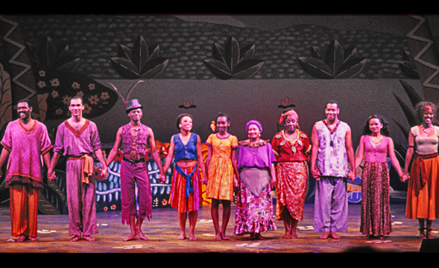

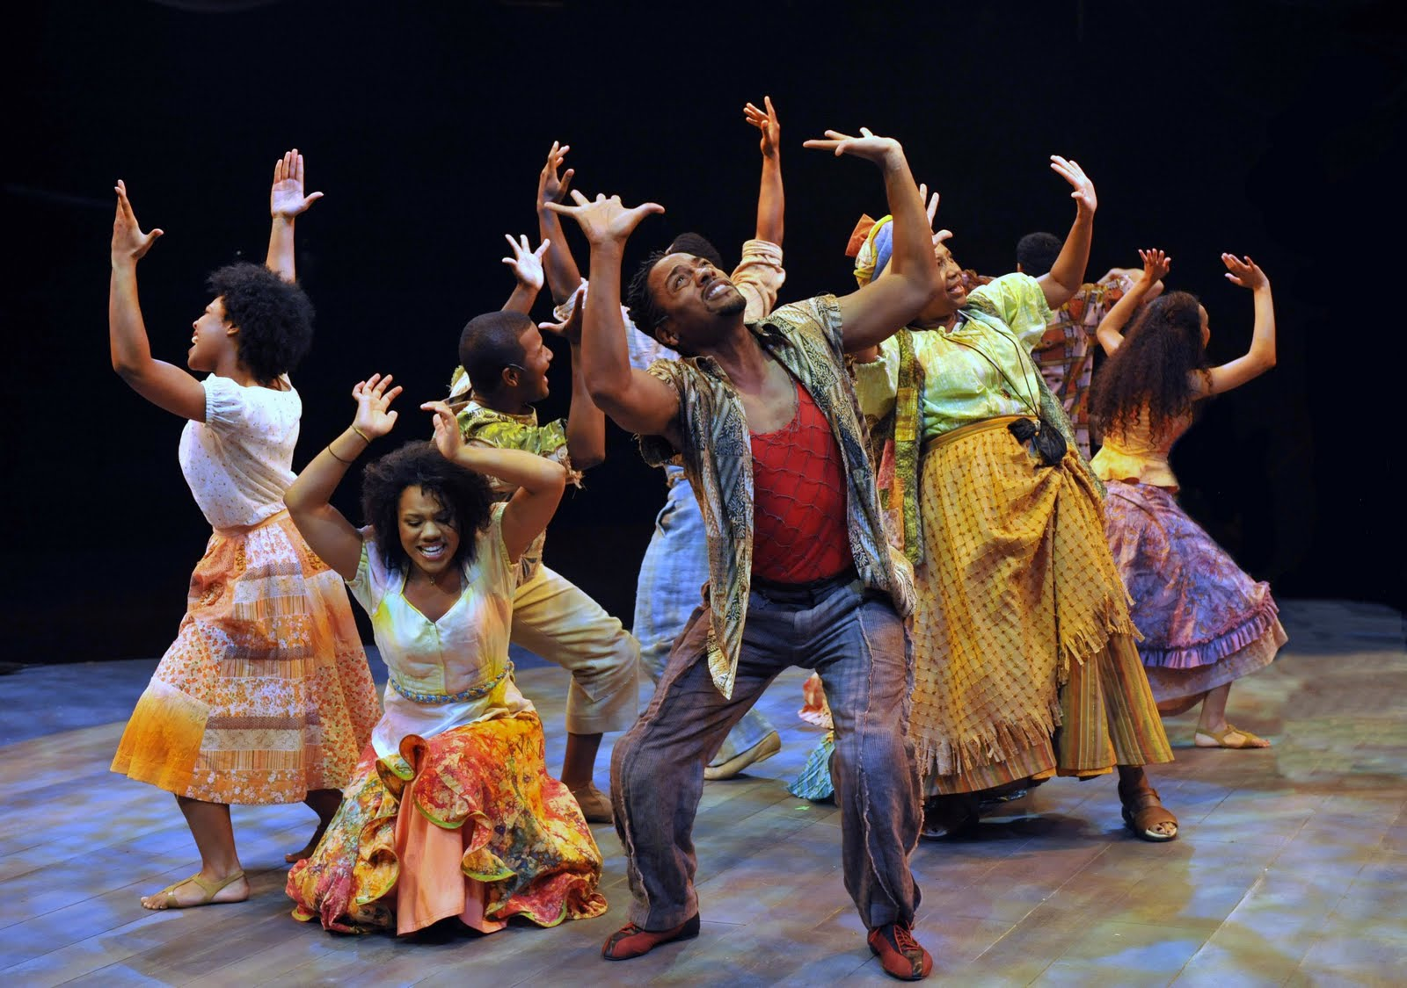

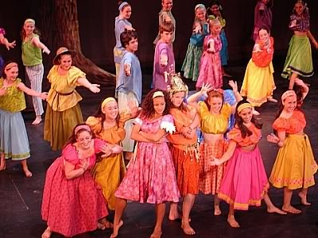
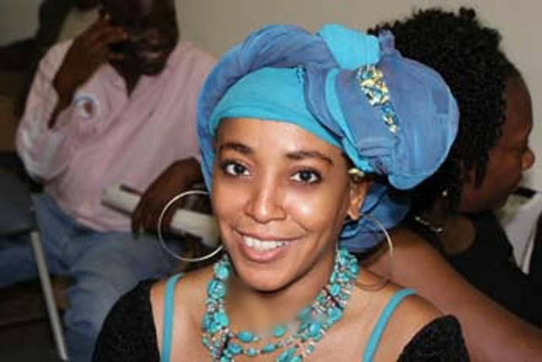

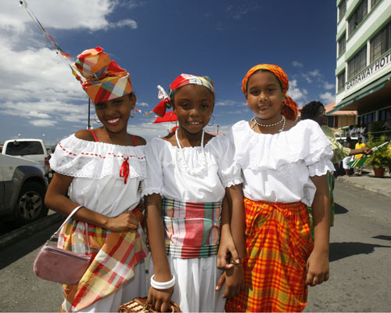
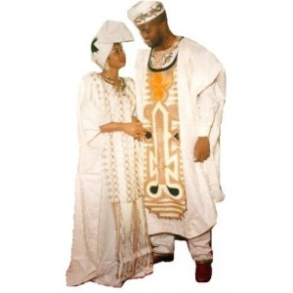

Beauxhommes/Daniel/Armand/Andrea/Little Daniel

Same style as the storytellers, but in plain white fabric. No patterns or colors. No shoes required. Head coverings are optional.

Gods

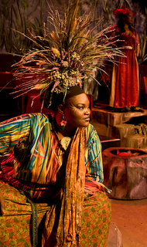
Asaka: Same as storytellers but with trinkets and a head dress that suggests that she is mother earth. She should have a lot of flowers, vines, and plant life on her person.
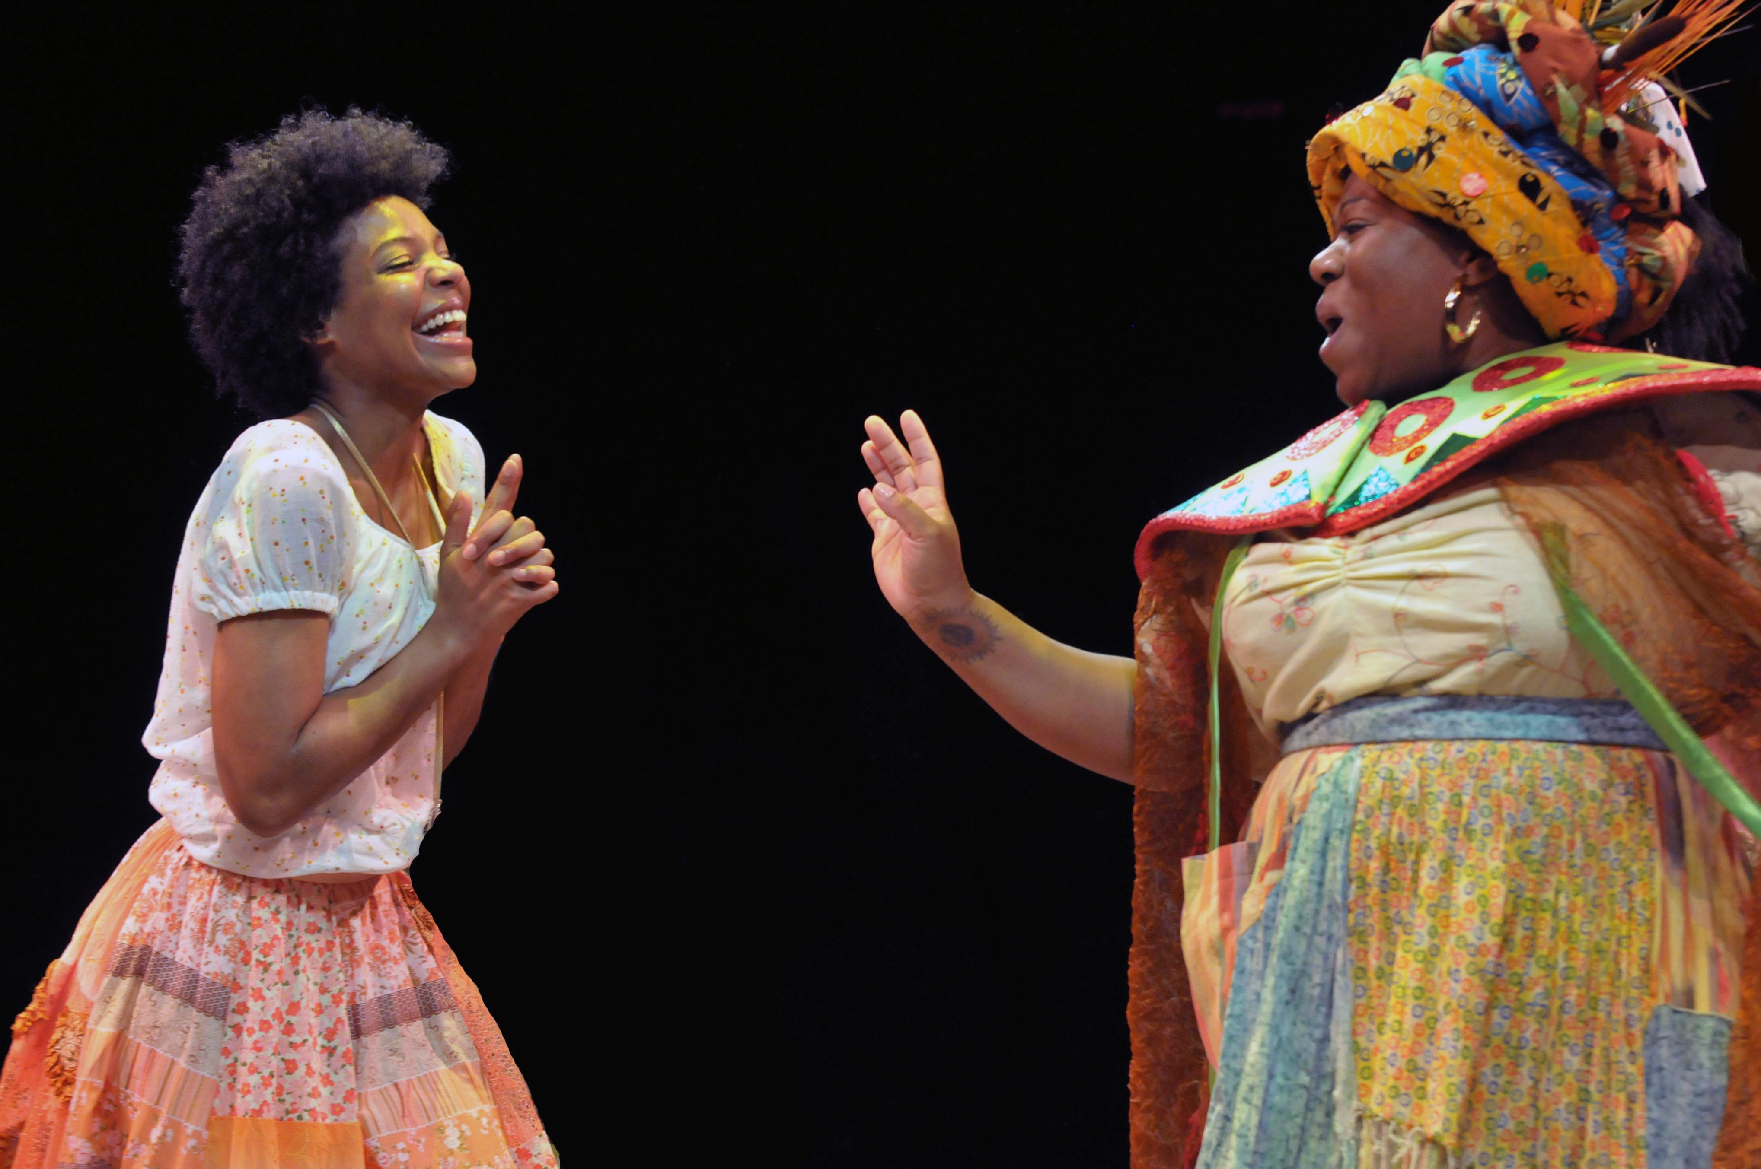
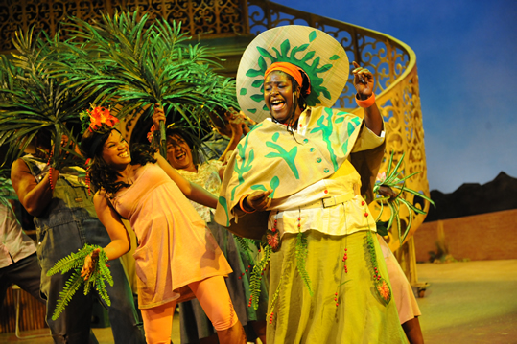
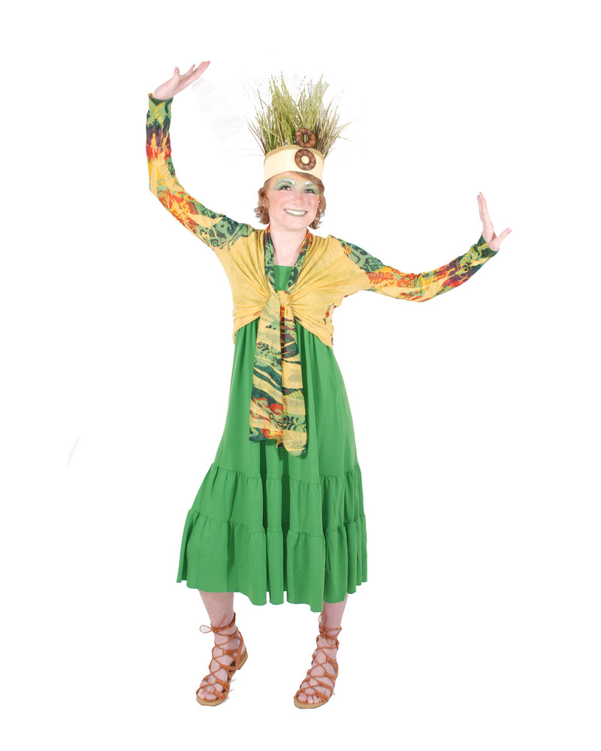
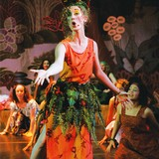

Erzulie: Same as storytellers but dressed in deep reds and magentas. Her costume should suggest that she is the goddess of love, so she may include trinkets or parts of her costume that suggest that as well.
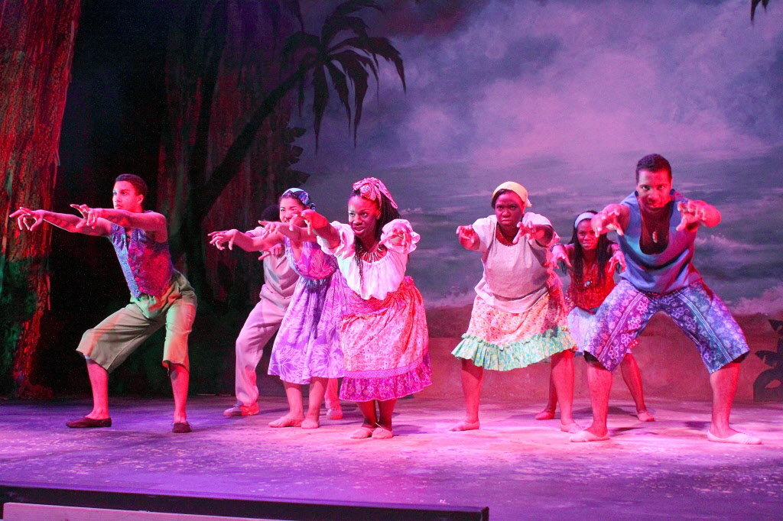

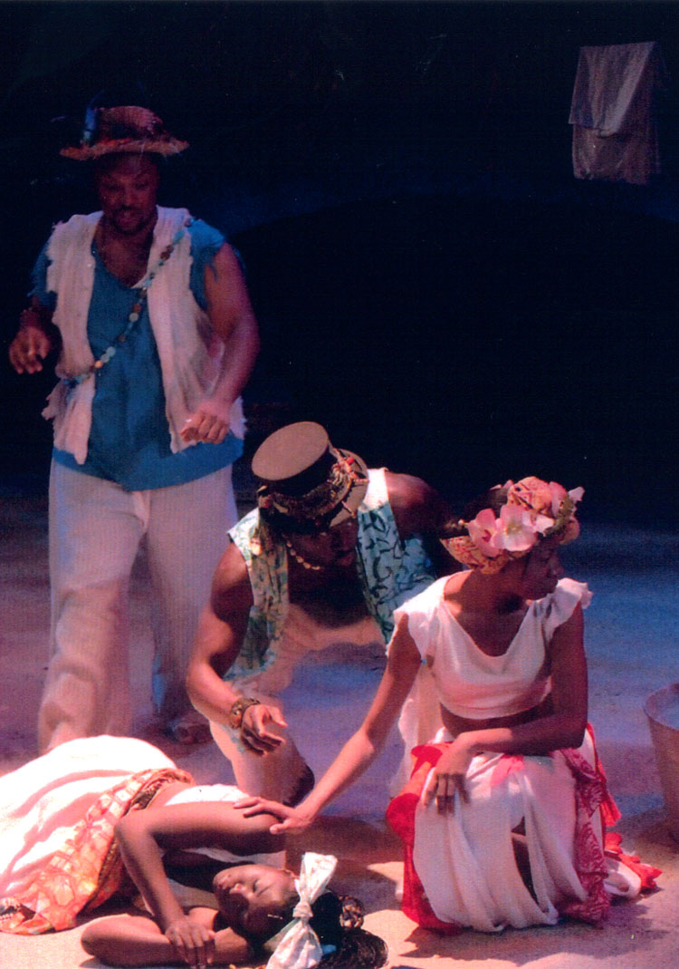
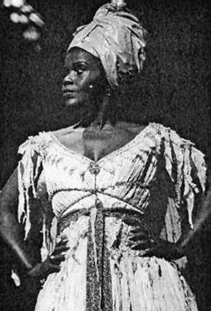

Agwe: Same as storytellers but dressed in shades of blue. He should also have a cape that suggests that he is part of the ocean and controls the water.

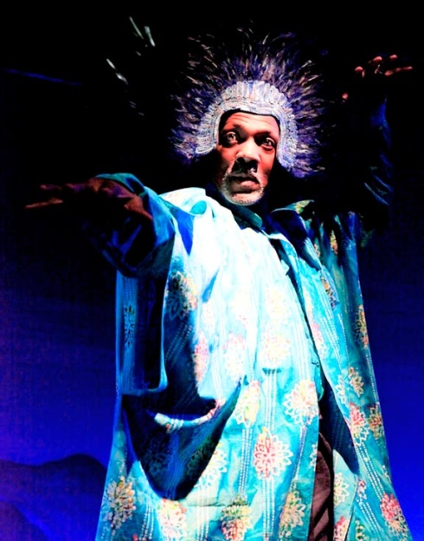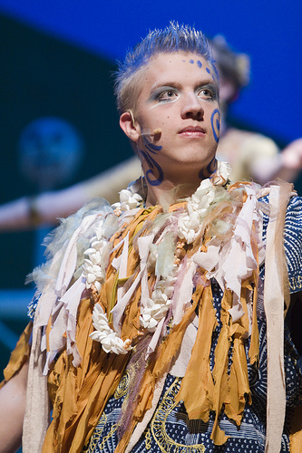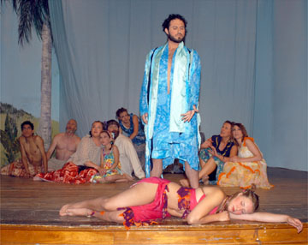

Papa Ge: Same as storytellers for pants. Needs a sleeveless shirt or vest. Should be dressed in deep purples and greys. Needs a top hat. Can have trinkets that suggest that he controls the element of death.
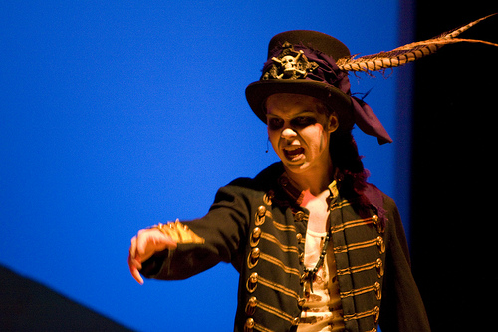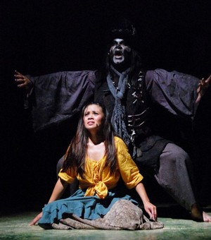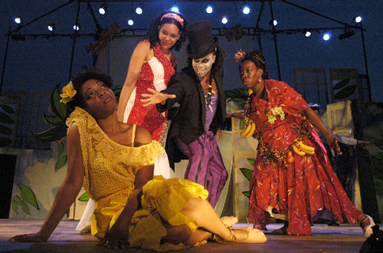
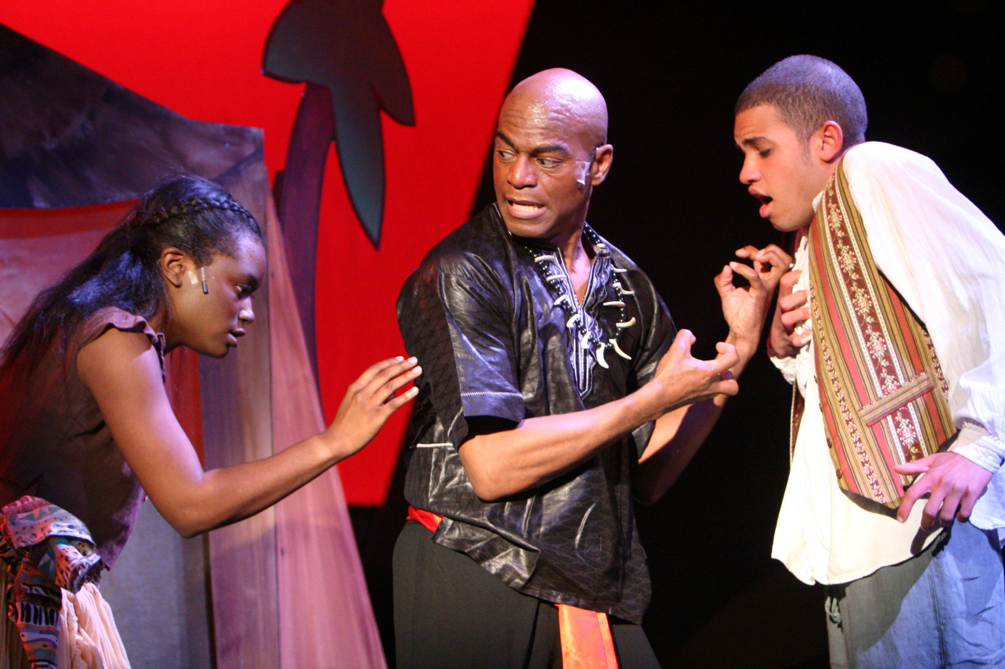
Once on This Island Parent Volunteer Form

Double casting is a double edged sword. It allows more students to participate, but it also means that it is far more time consuming on the production team’s end. This is where you come in. We are going to need a lot of parent help. We are looking for help with costumes, act-o-gram sales, set construction, backstage supervision, pot-luck dinners, etc. If you feel you can help in any of these areas, please fill out the form below. If you’ve already put your info on the disclosure document, we will be contacting you shortly!

My Name:_________________________________________________________

My Student:________________________________________________________

My email address:___________________________________________________

The best number to reach me:__________________________________________

Availability:________________________________________________________

I feel I can help in the following areas: (check all that apply)

- Act-o-grams
- Costumes
- Props
- Set Construction
- Pot-luck dinner for opening night
- Backstage supervision
- Painting sandwich boards
- Distributing show posters in the community
- Calling the newspaper for advertising
- Designing and printing programs and tickets
- Providing treats for the cast during dress rehearsals
- Painting the set
- Lighting
- Taking production photos
Once on This Island Needs

As of January 25, 2012 we need:

- As much fake greenery as we can get. Trees, plants, flowers, etc. Anything to help dress our set to make it look tropical
- Chicken wire to help sculpt our tree
- 4 black small parasols
- A wooden wagon or cart of some sort
- 2 beach mats
- Large sections of blue fabric for “Rain”
- People with plaster or paper mache skills to help sculpt our tree and landscape for the set
- 2 swords. Can be metal or wooden fencing foils
- 20 large white neutral masks
- Any type of fake fruit
- Several baskets with items that products that one would sell in a market place type atmosphere.

**UPDATES FOR THIS LIST WILL BE POSTED ON A REGULAR BASIS ON THE DRAMA WEBSITE WWW.WILLOWCREEKDRAMA.WEEBLY.COM

